Practical No. 14
Aim : ALP to count number of Even and Odd numbers in given array
Name : Danish Altaf Solkar Class : CO - B
Enrolment no. : 24111590805 Batch : 2

Code :-
assume cs:code
assume ds:data
data segment
arr DB 12H,09H,08H,05H,01H
e1 DB ?
od DB ?
data ends
code segment
start:
MOV AX,data
MOV DS,AX
MOV AX,0000H
LEA SI,arr
MOV CL,05H
MOV BL,02H
UP:
MOV AL,[SI]
DIV BL
CMP AH,00H
JZ DOWN
INC SI
INC DL
LOOP UP
JMP EXIT
DOWN:
INC SI
INC DH
LOOP UP
EXIT:
MOV e1,DH
MOV od,DL
INT 03H
code ends
end start

OUTPUT :-
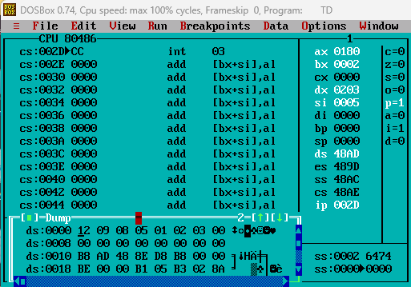

Process related  (15) | Product related  (10) | Total Marks  (25) | Signature

